Name: ___________________________ Feudalism
Feudalism: the dominant political system in Europe between the 9th & 15th centuries
THINK: Who holds power in our modern society?

CONSIDER: How is that organised and why? Who benefits?

The feudal system was based on class and hierarchy:
- The Pope was at the peak of the feudal system and the king was accountable to the church
- Nobles such as Dukes, Barons and Lords were given lands in return for their allegiance to the king
- Soldiers, farmers and craftsmen served the nobles on their lands
- Peasants worked the lands to feed themselves and to provide for the nobles, but had no rights

THINK: Do class systems like this exist in our modern society?

CONSIDER: How we might view others as different classes

Usually, kings or emperors did not have large enough standing armies or enough educated men to control vast areas of territories. Kings used the feudal system to give land to important nobles or lords who benefited from the wealth of their given region through agriculture and taxes. In return, the lords would pass on some of those taxes and also promise to fight for their king when necessary, making them vassals to the king.

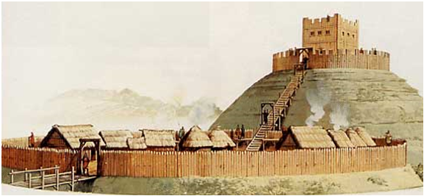
The nobles controlled what were termed as ‘fiefdoms’ and they became the legal authority over those lands, owning all resources and properties, making them immensely powerful.
The feudal system relied on those lower in the class structure to defend and fight for their lord in return for land and protection. Competition between medieval landowners through the desire for land and the wealth it produced was fierce. Landless knights scoured the lands for opportunities to advance their standing. Whole communities suffered when wars ravaged areas. Fortified structures therefore became a feature of the land. Castles grew out of the Roman idea of a stronghold or ‘castrum’. Castles were built to control road junctions, river crossings, mountain passes ports and important towns or villages.

The first castles appeared in the Loire valley in France during the 10th century. Castle building spread through Europe with stone structures replacing the earlier wooden defences.
The earliest castles were built on a high mound of earth called a ‘motte’: easier to defend from and it provided a clearer view of the surroundings. A tower, or ‘keep’ was built on the ‘motte’, this is where the lord and other nobles lived. Around the motte was the ‘bailey’ where soldiers, horses, the kitchen and stores existed.

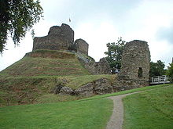
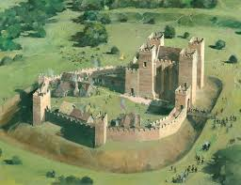

The Pope had the power to excommunicate anyone from the Church – removing the chance to be forgiven for their sins. The Church was also divided upon class structure: the higher clergy were the bishops, a type of noble; the lower clergy were the priests, pastors, nuns and monks who communicated with the ordinary people, or commoners, fulfilling social functions, educating, caring for the sick and offering shelter to those in need.

The commoners were also referred to as peasants. Some peasants owned land given to them by the lord, others, called ‘serfs’ simply worked for someone and owned no land.

Most people lived in the country, but towns were growing and some commoners started to make money through businesses. This group began to grow in number, wealth and influence, creating tension in the social structure.

THINK: What similarities do you see in the feudal system that can be observed in our present social structure?

CONSIDER: How have things have changed in our social structure since the medieval era?

CONSIDER: What elements of social structure do you see that have continued since the medieval era?

